RAKBANK - DevOps Position Assessment

Deploying a Java Application to AWS EKS using GitHub Actions and IAC with Terraform Objective: Candidates are required to demonstrate their proficiency in DevOps practices by deploying a Java application to Amazon Elastic Kubernetes Service (EKS) using GitHub Actions for CI/CD and Infrastructure as Code (IaC) with Terraform.

Submitted By
Hina Ikram

Solution:
GitHub repo Link: https://github.com/Hinaikram/RBSpringBoot-K8.git
Github repo for Terraform: https://github.com/Hinaikram/RBTerraform-EKS.git

Procedure to deploy Spring Io application
- Open the link to download the Jave web base application following the link.
- https://start.spring.io/
- Choose the following option:
  - Maven
  - Nnn
- Add web dependencies
  - Spring web
  - lombok

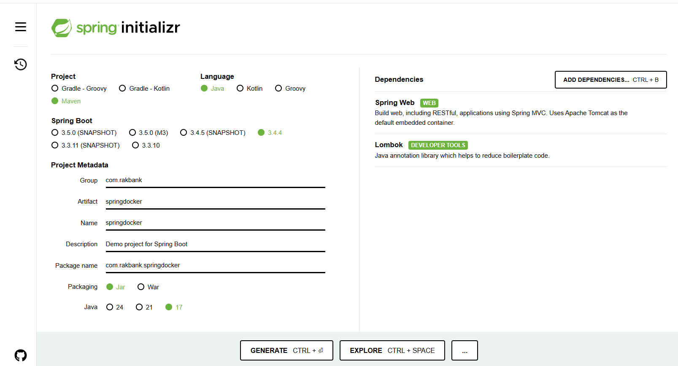

- Generate the zip package, which will be downloaded.
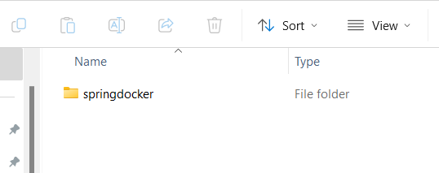
- Open the project in any version control, Visual Studio. Add the class and controller in the project.
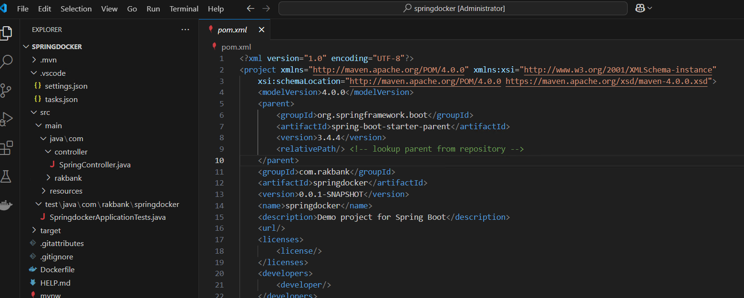
- Build the project, using the pom file.The build is success full.
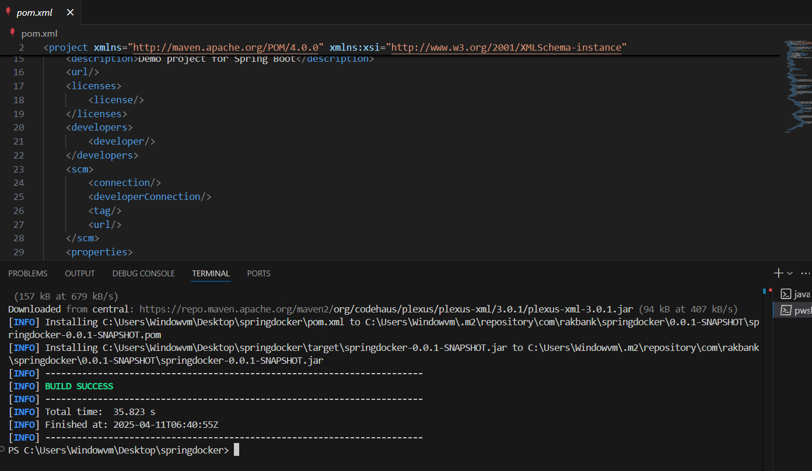
- Create a Dockerfile at the root folder. Port 8080 is being used.
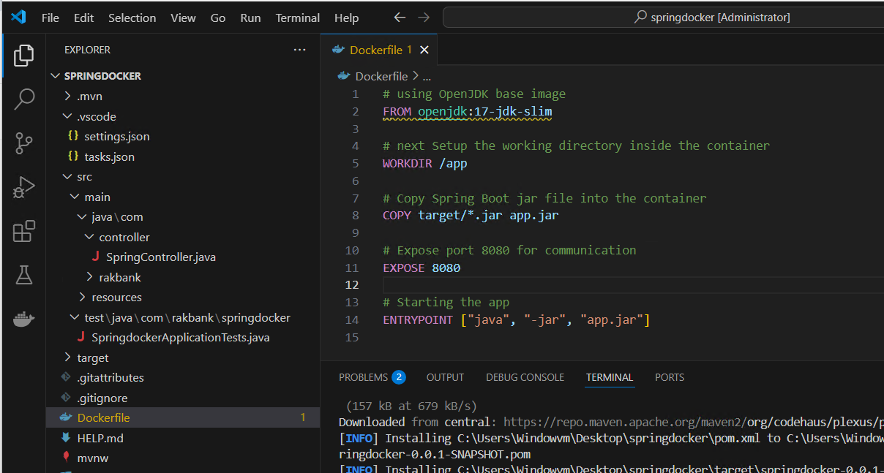
- Initialize the Git repo for the project, using your credentials
  - Git init
  - Git add .
  - Git commit -m “ Rakban Assessmet”
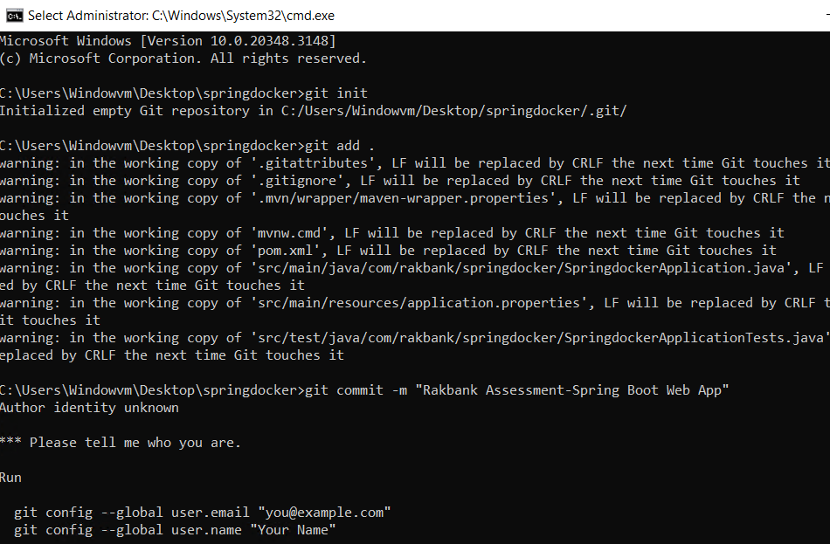
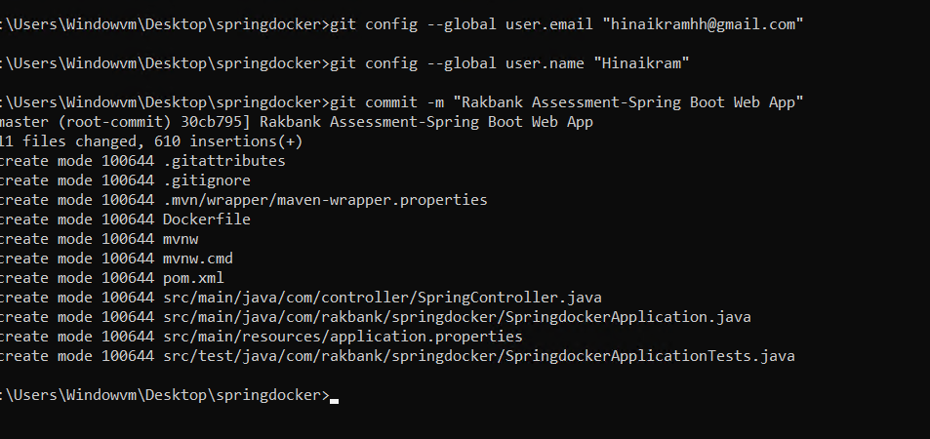
- Create a repository in the Github account without the readme file as we have already initialized it in the project folder.

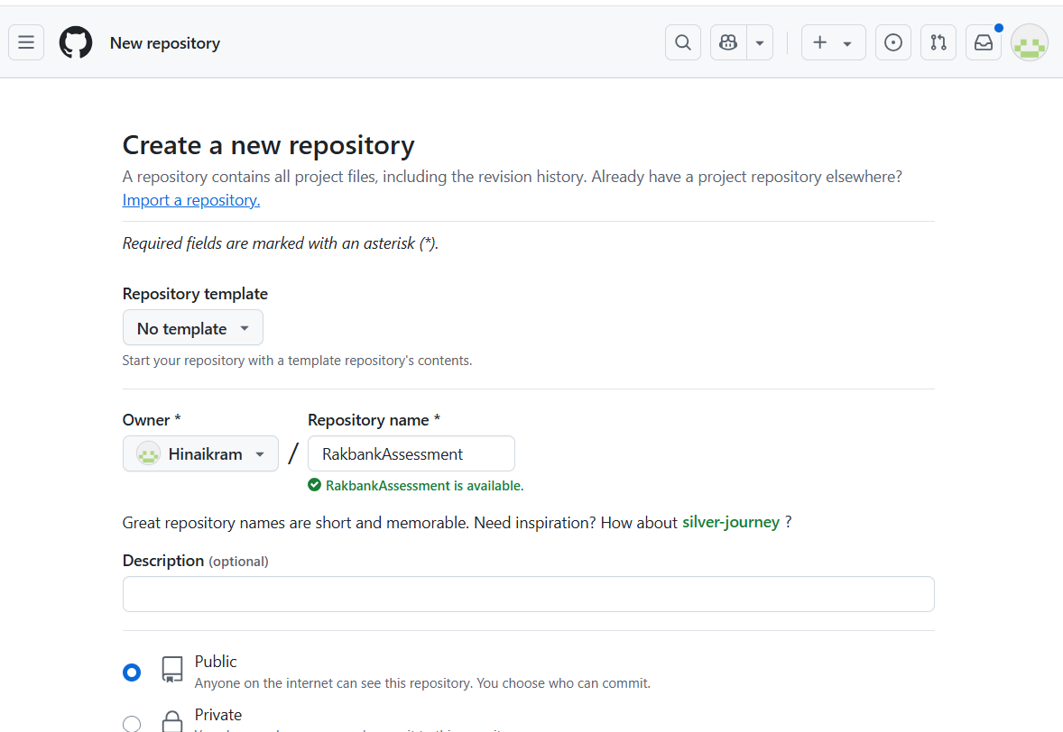
- Now push the code in repository.

  - git remote add origin https://github.com/Hinaikram/RakbankAssessment.git
  - git branch -M main
  - git push -u origin main
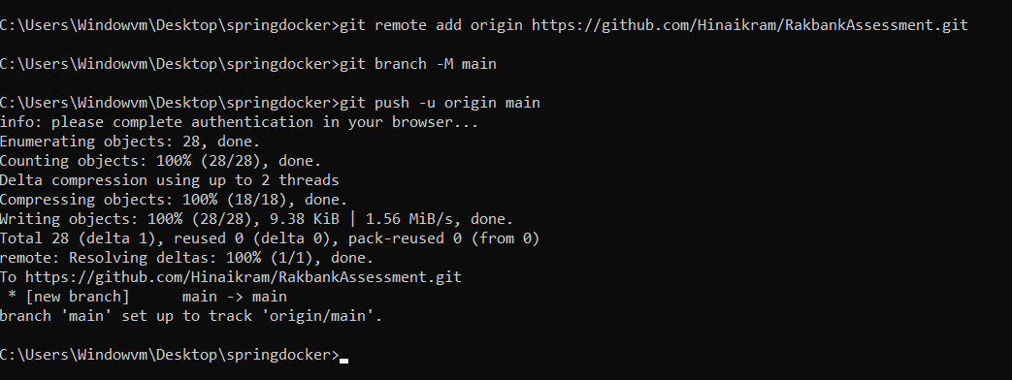
- Refresh the browser page and repo will be updated.

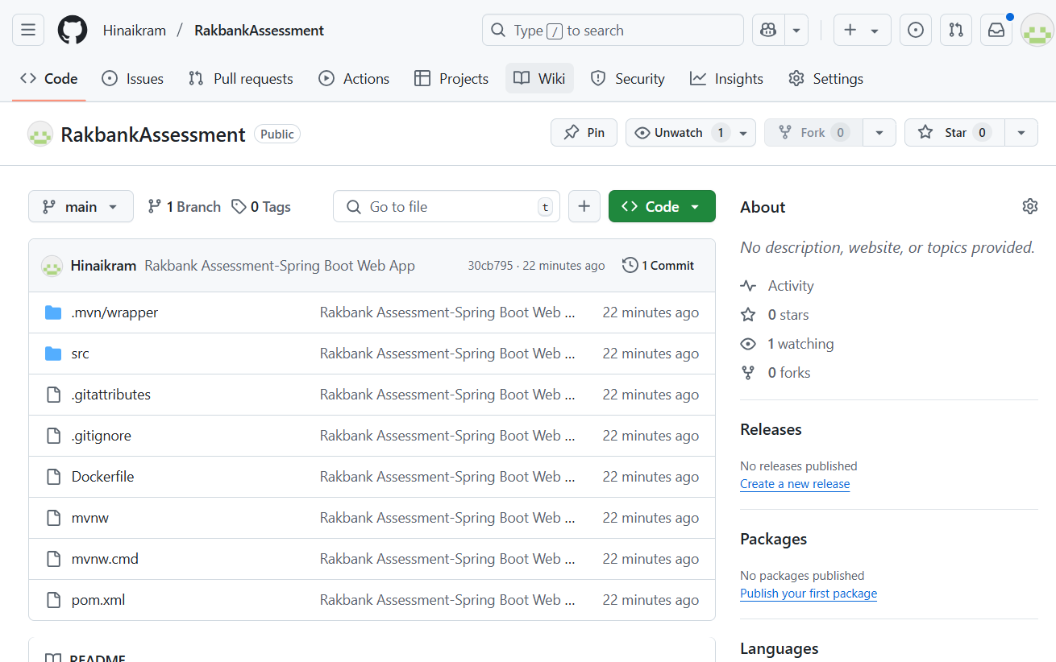
- Now build a docker image using the Git repo
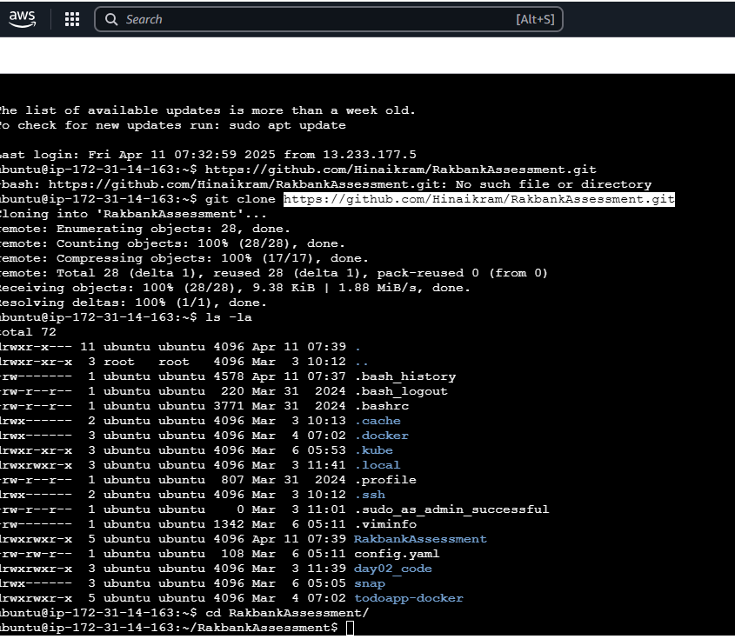

- Run the docker image
  - docker build -t springboot-app .
  - docker run -d -p 8080:8080 springboot-app
- Crete a cluster
  - eksctl create cluster --name rbcluster --region ap-south-1
  - kubectl apply -f C:\springdocker1\springdocker\kubernetes/deployment.yaml
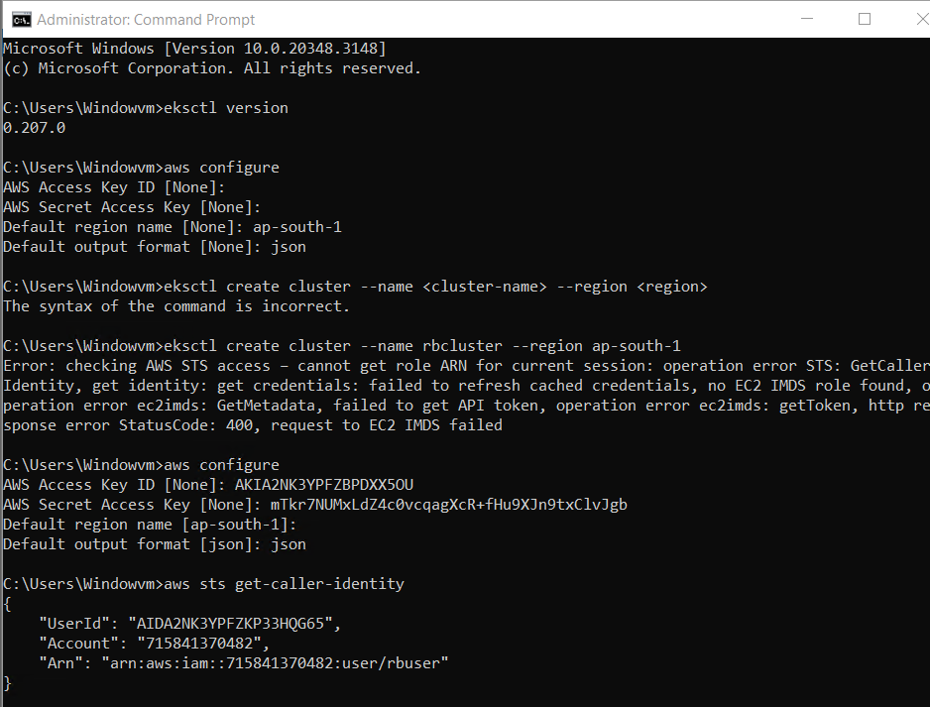

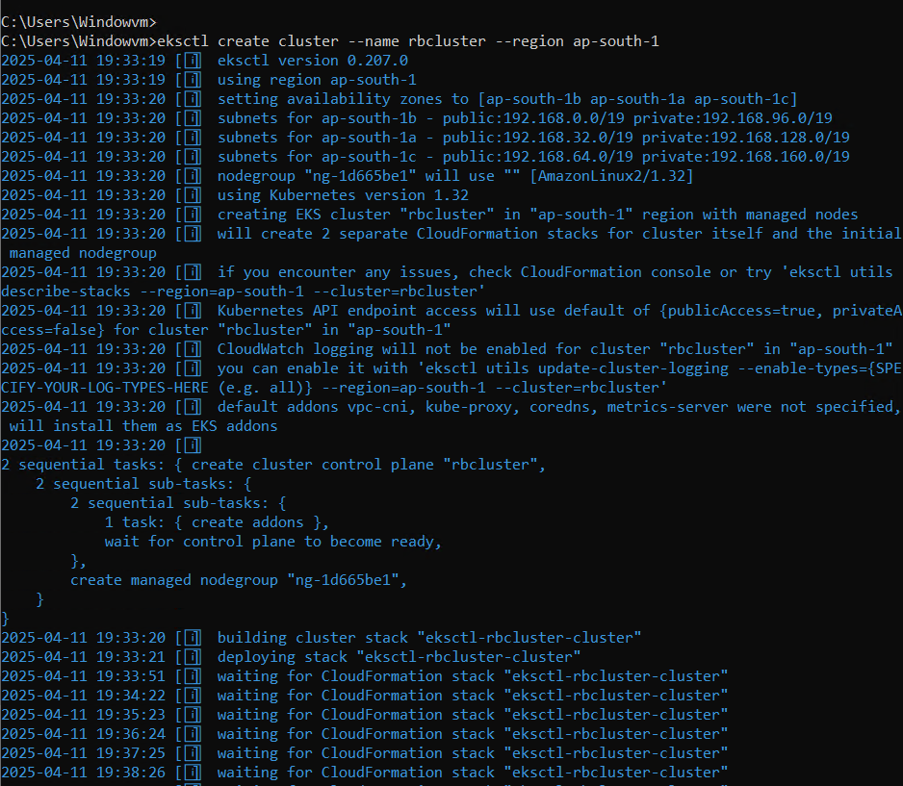

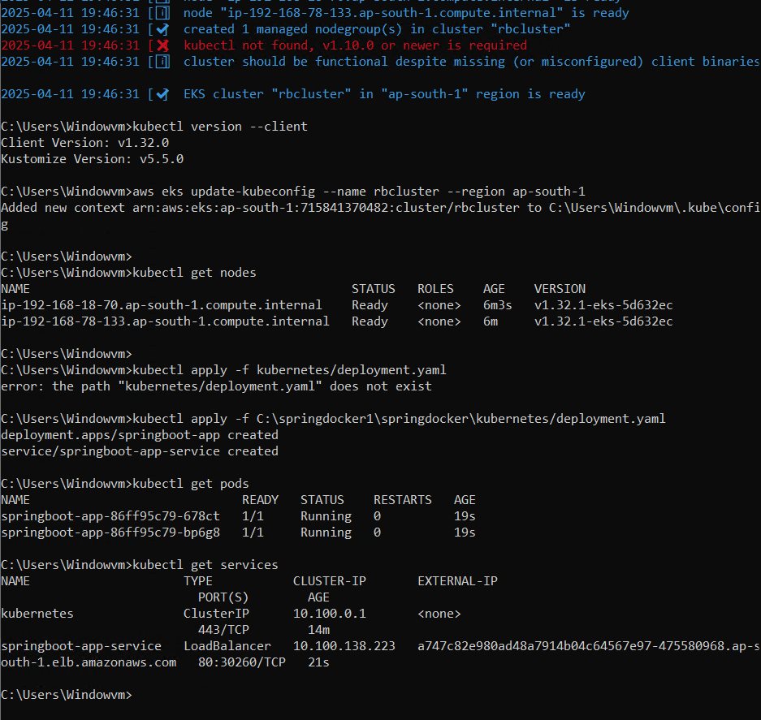

- Cluster has been configured and full functional.
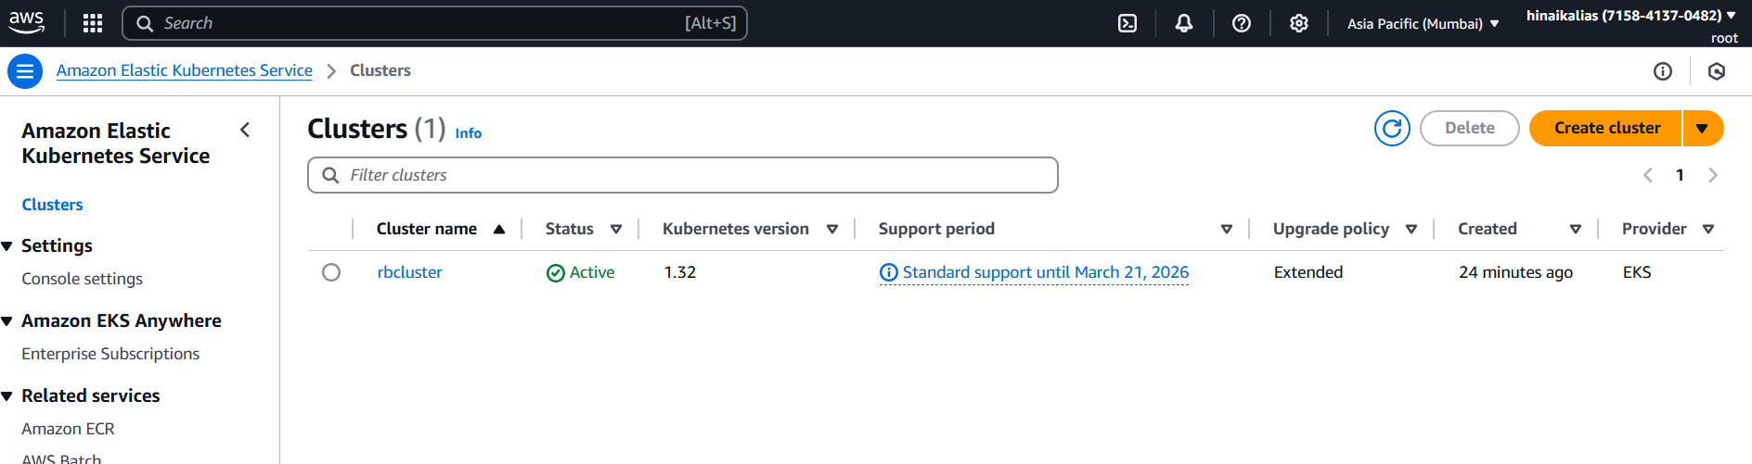

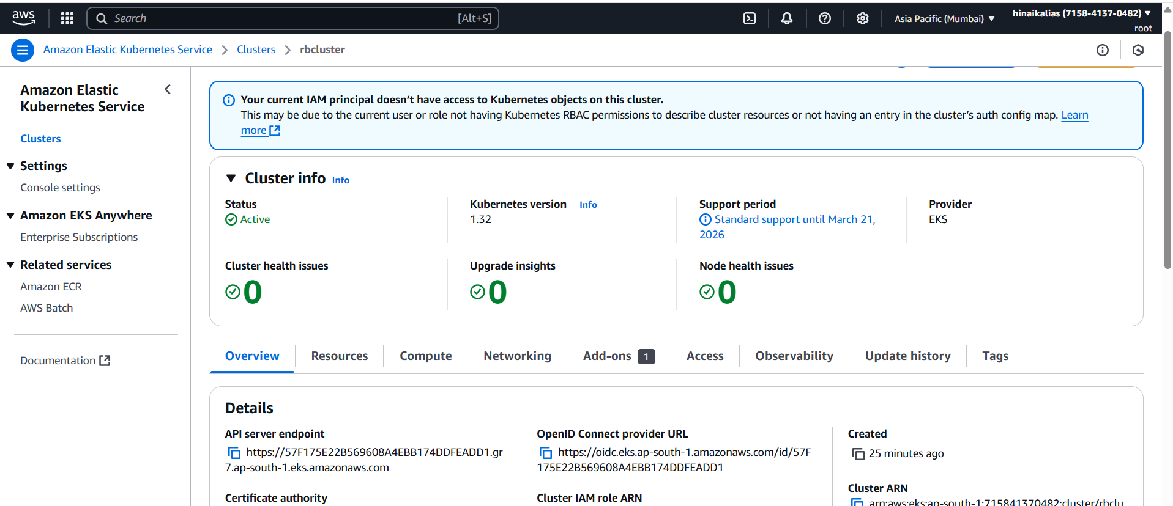

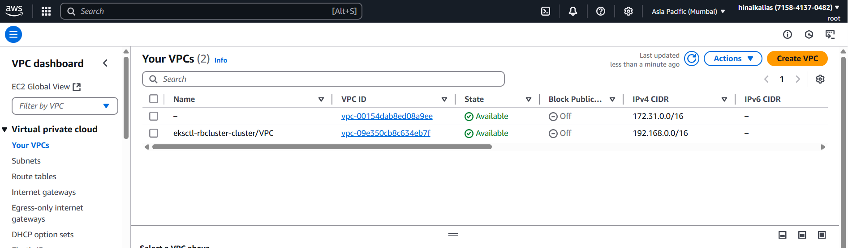

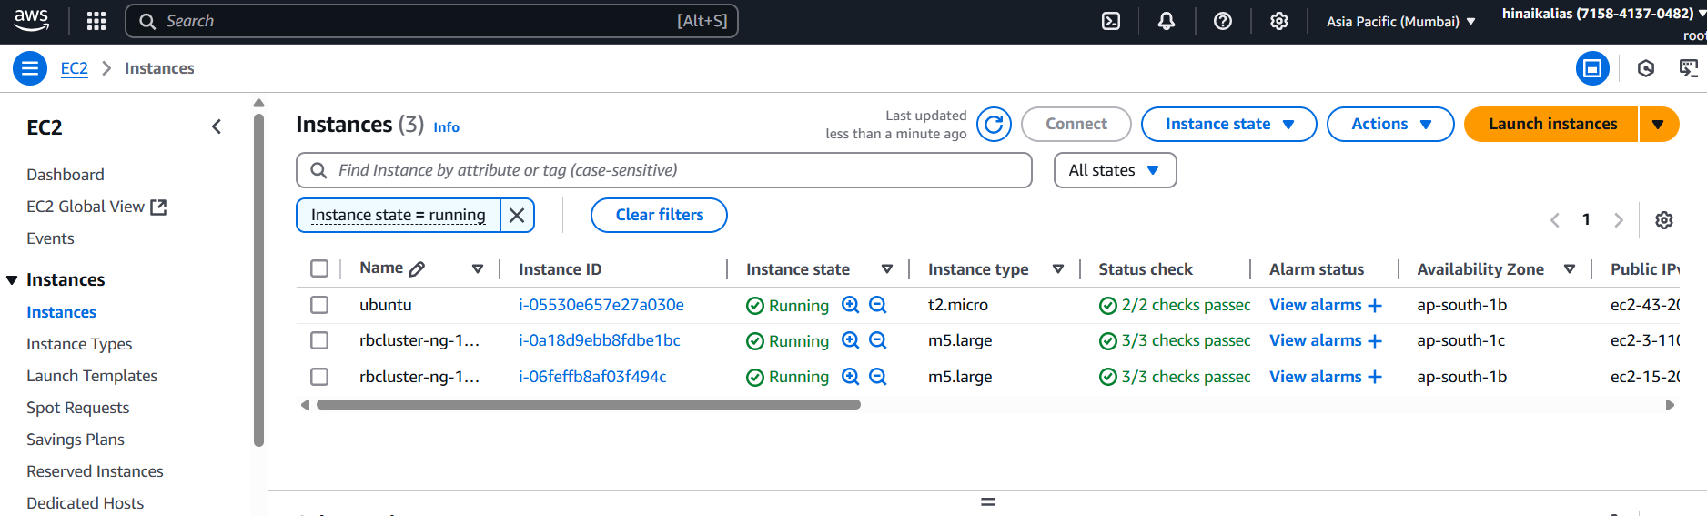

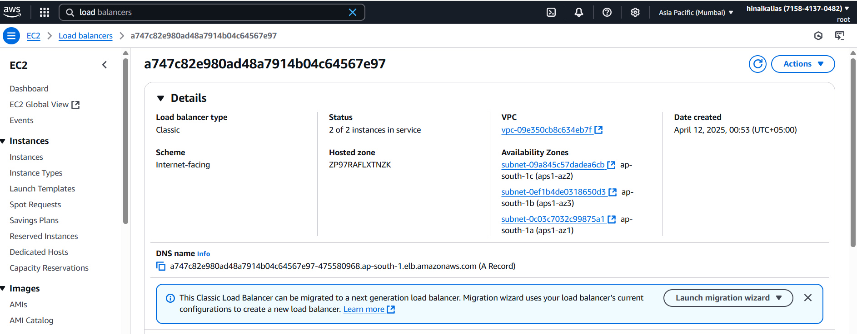

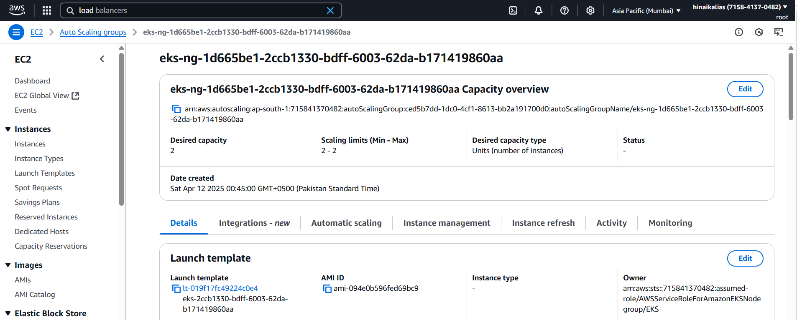

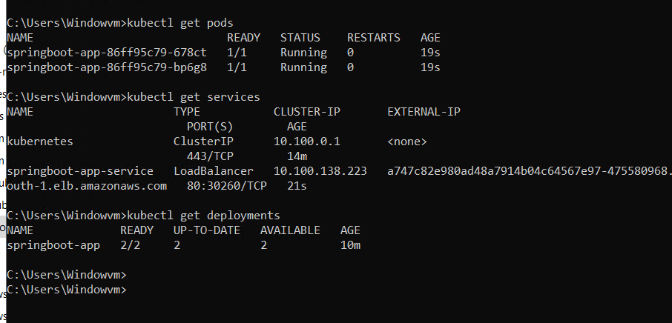

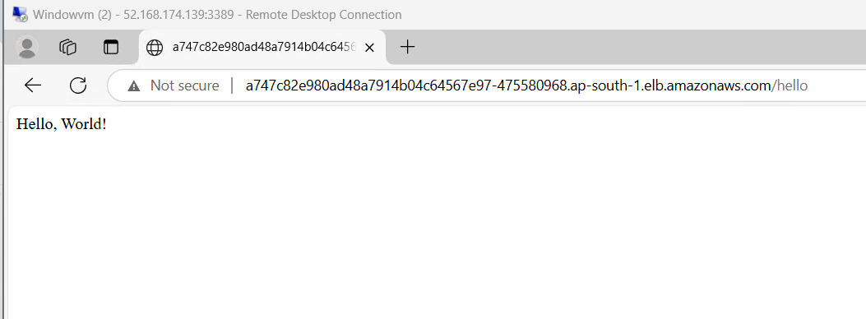

Helm charts
Helm charts are package managers for Kubernetes applications, allowing you to define, install, and upgrade even the most complex Kubernetes apps.
- helm upgrade springboot-app .
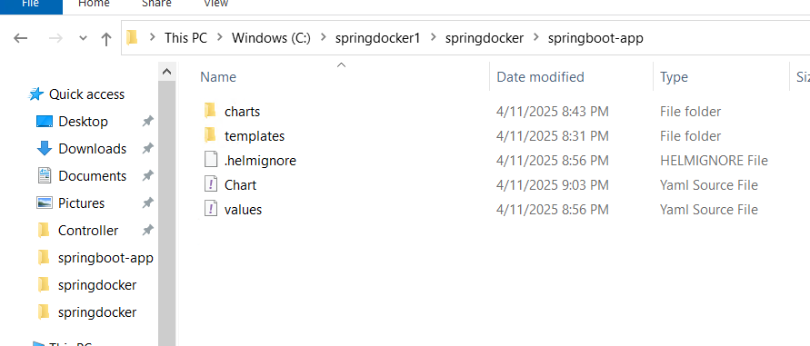

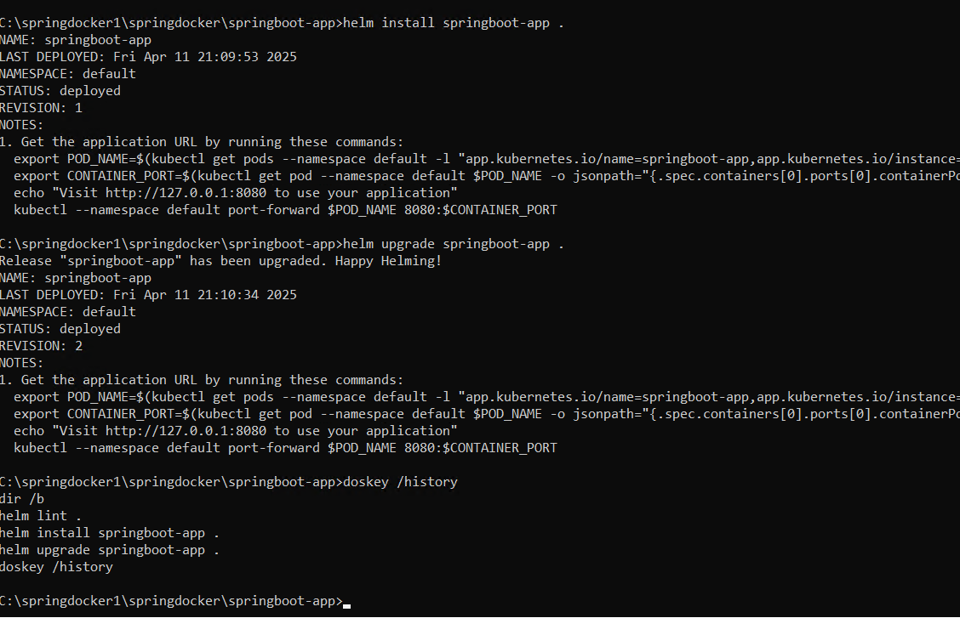

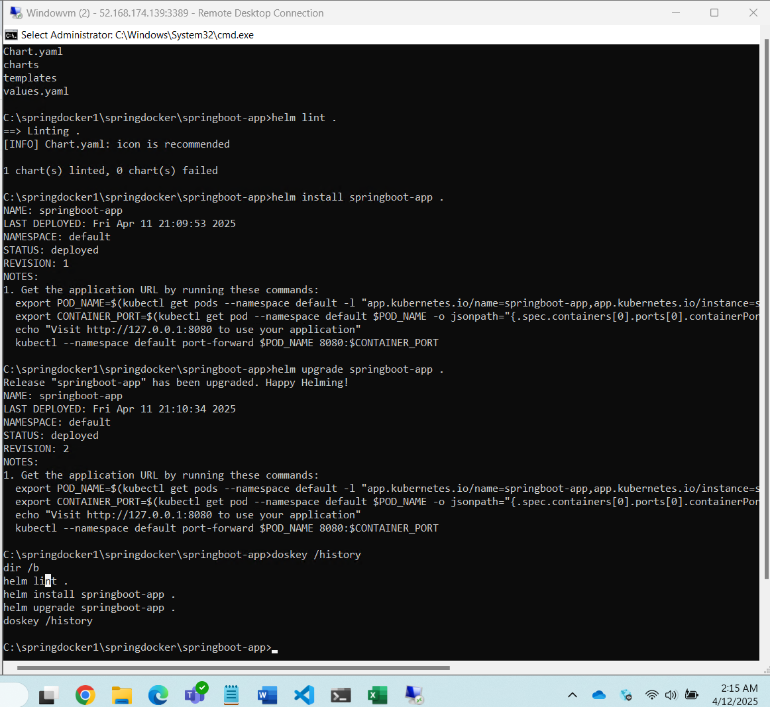

Destroy the cluster
- eksctl delete cluster --name rbcluster --region ap-south-1

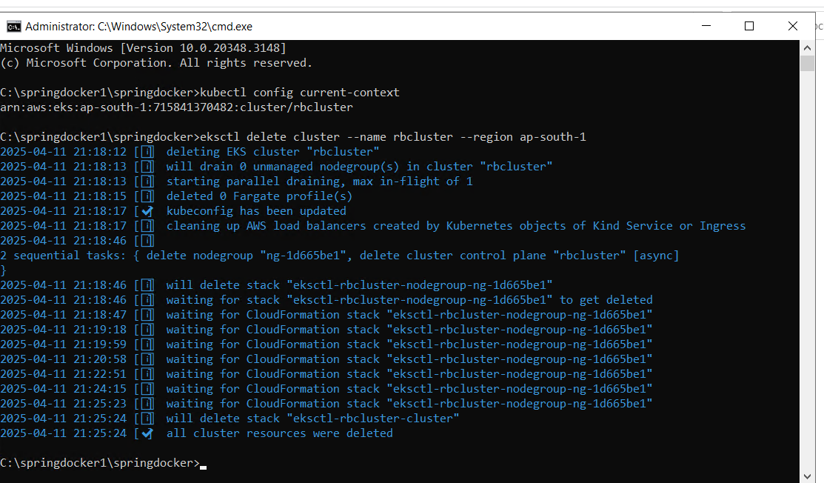

Terraform Kubernetes
To create an Amazon EKS (Elastic Kubernetes Service) cluster, several AWS resources are required to ensure proper networking, security, and compute capabilities.
- VPC – to isolate your cluster and its networking.
- Private Subnets – for deploying worker nodes (one per Availability Zone for high availability).
- Public Subnet – to allow internet access (e.g., for NAT gateway or load balancer).
- Internet Gateway – attached to the VPC to enable outbound internet access.
- NAT Gateway – to allow private subnet instances (nodes) to reach the internet.
- Route Table – configured to route traffic appropriately between subnets and gateways.
- IAM Role for EKS Control Plane – to allow EKS to manage AWS resources.
- IAM Role for Worker Nodes – for node instances to communicate with AWS APIs.
- EKS Cluster – the managed Kubernetes control plane.
- 1 Managed Node Group (EC2) or Fargate Profile – to run containerized workloads.
- Security Groups – to control inbound/outbound traffic to cluster and nodes.
- kubectl + aws-iam-authenticator – on your local/dev machine to interact with the cluster.

